ECON0004 TUTORIAL 4
Deadline for submission is 11:59pm on Friday, 8th March, 2026.

Submission Instruction:
Similar to the previous assignment, you are expected to submit two files:
1. Main submission (Word or PDF), which should include your answers to all questions. 2. Jupyter Notebook, which includes the code used to answer the relevant parts in Question 3.

Q1. Suppose in 2018 the government introduces a new policy targeted at decreasing unemployment amongst disadvantaged groups in designated areas of high unemployment. One part of this policy is an employment rehabilitation policy that provides a subsidy to employers for every worker they employ with a criminal record. Data are collected on the unemployment rates of a group of workers without criminal records (group A) and a group of workers with criminal records (group B) before and after the policy is introduced.
 | 2017 (before) | 2019 (after)
Group A: No criminal records | 23.25% | 20.37%
Group B: criminal records | 49.46% | 42.86%

- Using the data in the table above, calculate an estimate of the effect of the policy on the unemployment rate. Be clear about how you would calculate it. Illustrate the difference-in-differences estimator of the effect of the policy graphically.
The effect of the policy is calculated by (“delta” B- “delta” A) = -3.72%
- 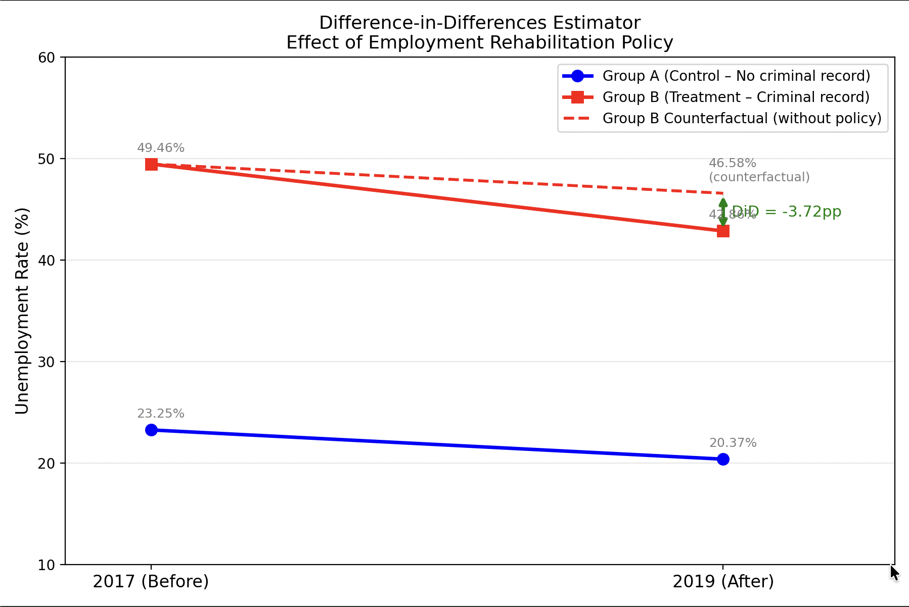Carefully explain the assumptions required for the difference-in-differences estimator to be valid. Are these reasonable in this case?
The assumption required for the difference-in-differences estimator to be valid is that the policy is the sole reason why unemloyment among Group B decreases further than the natural trend of unemloyment reduction (Group A)

- In order to evaluate this policy, you run the following regression:
Unemployment_{i}=β₀+ β ₁After_{i}+ β₂Treat_{i}+ β₃After_{i}*Treat_{i}+ε_{i} Where Unemployment_{i} is a dummy variable equal to 1 if the observation i is unemployed and 0 otherwise; After_{i} is a dummy variable that takes the value 1 if the observation i is in year 2019 (after the policy is introduced) and 0 otherwise; Treat_{i} is a dummy variable that takes the value 1 if the observation i is from treatment group and 0 otherwise; After_{i}*Treat_{i} is the interaction between the two variables; ε_{i} is the error term.

Which regression coefficient will measure the difference-in-differences estimate of the policy? Show the derivation and explain your answer.

- What are the advantages of implementing the difference-in-differences estimator using a regression, rather than the simpler method described in part (a)?

Q2. An American fast-food chain specialized in coffee and bagels recently entered the London market. The CEO of the company wants to know more about the London market and commissions a survey, in which a representative sample of the London population is asked about its consumption of coffee and bagels, as well as age and income. The CEO hands you these data to analyse and you decide to run a double log demand regression. You run two
OLS regressions giving the results displayed in column (1) and column (2) of the table below.

Market: | Lo | ndon | New York
Dependent variable: | (I)  Ln Coffee | (2) Ln Bagels | (3) Ln Coffee | (4) Ln Bagels
Ln Price  Coffee  Ln Price  Bagels  Ln income  Age | -0.8540  (0.385)  -0.3590  (0.127)  0.2030  (0.158)  0.1070  (0.010) | -0.3650  (0.137)  -0.4590  (0.127)  0.8790  (0.185)  -0.0896  (0.078) | -0.3946  (0.205)  -0.7940  (0.362)  0.1460  (0.078)  0.0070  (0.010) | 0.4530  (0.237)  -1.5680  (0.203)  0.2430  (0.005)  0.0074  (0.045)
Note: Standard errors in parentheses. "Ln" refers to the natural logarithm.

- Why are the estimates calculated using only data on consumers who purchase coffee and bagels? Should this be a source of concern?

- Based on regressions (1) and (2), can you reject that coffee is price elastic in the
London market? Can you reject that bagels are price elastic in the London market?

- Are coffee and bagels estimated to be substitutes or complements in regressions (1) and (2)? Are the conclusions consistent across different demand equations?

- The CEO of the company wants to know the difference between London market and New York market. You run the same regression using survey data on individual consumption of coffee and bagels in New York. The regression results are reported in columns (3) and (4) of the table above. Are bagels more price elastic in New York or in London? Considering that bagels are a relatively new product in the UK, give one factor that could explain the difference.

Q3. Answer questions 1 and question 2 in Part 3.1 Before-and-after comparisons of retail prices of empirical project 3 “Measuring the effect of a sugar tax” (working in Python) in the e-book “Doing Economics: Empirical projects”.

Note that the recommended way to load the dataset into Python is to first download the dataset to your current working directory, and then use the Python code you have learned to import it.
1. Read ‘S1 Text’, from the journal paper’s supporting information, which explains how the Store Price Survey data was collected.
a) In your own words, explain how the product information was recorded, and the measures that researchers took to ensure that the data was accurate and representative of the treatment group. What were some of the data collection issues that they encountered?
The product information was recorded through a survey called Store Price Survey (SPS). The measure taken to ensure accurate and representative data was to randomly select stores in the area of Berkeley from a list of licensed businesses. They issue that they encountered however was that some stores refused to allow their data to be collected.
b) Instead of using the name of the store, each store was given a unique ID number (recorded as store_id on the spreadsheet). Verify that the number of stores in the dataset is the same as that stated in the ‘S1 Text’ (26). Similarly, each product was given a unique ID number (product_id). How many different products are in the dataset?
To verify the number of stores in the dataset are the same as stated in the text we can print then number of rows on python and look under the “store_id” column. For under product_id, there are the same amount as well. In this case, the row counting line on python has to put “unique()” to make sure that the stores are only counted once

Following the approach described in ‘S1 Text’, we will compare the variable price per ounce in US$ cents (price_per_oz_c). We will look at what happened to prices in the two treatment groups before the tax (time = DEC2014) and after the tax (time = JUN2015):

treatment group one: large supermarkets (store_type = 1)
treatment group two: pharmacies (store_type = 3).

Before doing this analysis, we will use summary measures to see how many observations are in the treatment and control group, and how the two groups differ across some variables of interest. For example, if there are very few observations in a group, we might be concerned about the precision of our estimates and will need to interpret our results in light of this fact.

We will now create frequency tables containing the summary measures that we are interested in.

2. Create the following tables:
a) A frequency table showing the number (count) of store observations (store type) in December 2014 and June 2015, with store_type as the row variable and time_period as the column variable. For each store type, is the number of observations similar in each time period?
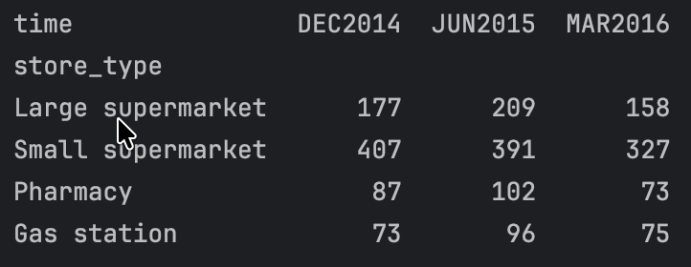
The number of observations in each time period are not the same, me think

b) A frequency table showing the number of taxed and non-taxed beverages in December 2014 and June 2015, with store_type as the row variable and taxed as the column variable. (Taxed equals 1 if the sugar tax applied to that product, and 0 if the tax did not apply). For each store type, is the number of taxed and non-taxed beverages similar?

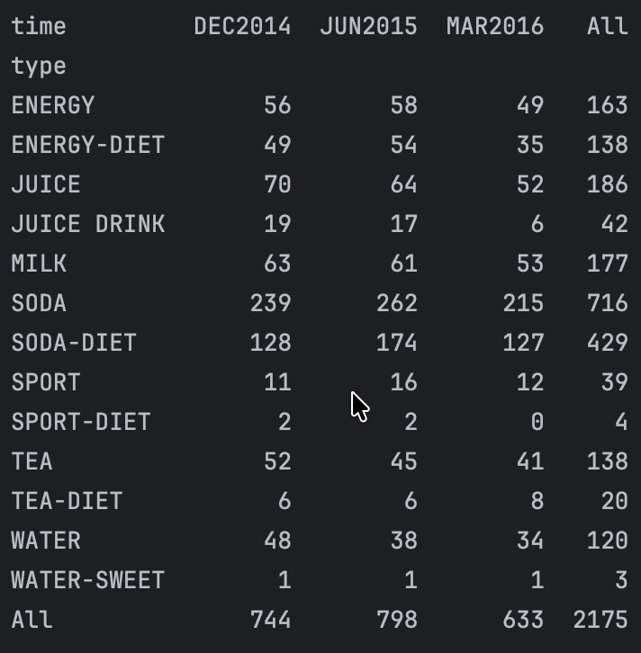

c) A frequency table showing the number of each product type (type), with product_type as the row variable and time_period as the column variable. Which product types have the highest number of observations and which have the lowest number of observations? Why might some products have more observations than others?

